**How to execute ultrasonic blind stick:**

**🡪Inserting the code into arduino UNO**

**How to upload the code:**

The Arduino IDE consists of few example sketches which can be uploaded to Arduino board by using following steps:

1. Double-click the Arduino application.

2. Open the LED blink example sketch: File > Examples > 1.Basics > Blink

3. Select Arduino Uno under the Tools > Board menu.

4. Select serial port (if not aware of exact port, disconnect the UNO and the entry that disappears is the right one.)

5. Click the Upload button.

6. After the message “Done uploading” appears, the LED on Arduino will start blinking once a second.

**🡪How to upload voices into voice playback module(APR33Avoice processor)**

The APR33A series are powerful audio processor along with high performance audio analog-to-digital converters (ADCs) and digital-to- analog converters (DACs).

Steps:

1. MODE SWITCH – Select the switch to play mode or record mode

2. Long press the button while recording and release the button when recording finished.

🡪**connections:**

**Ultrasonic connection:**

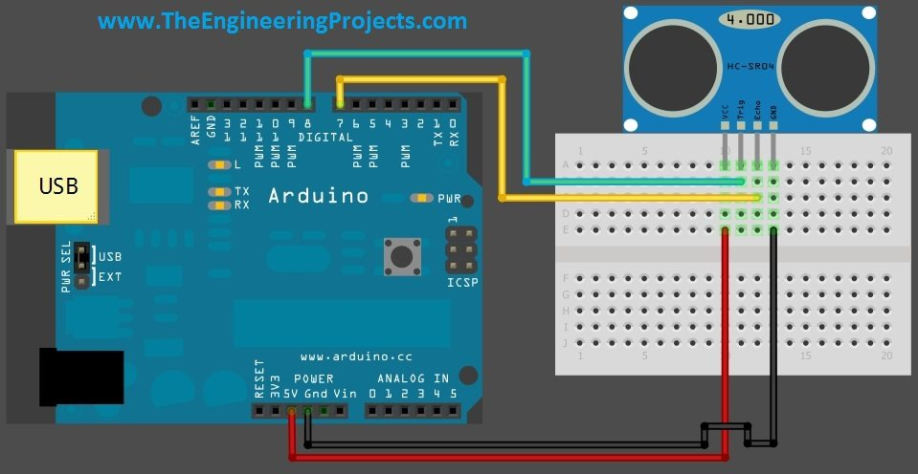

**Voice Module connection:**

M1,M2,M3,M4,M5,M6 pins in **APR33Avoice processor** are given to 8,9,10,11,12,13 pins to record voices, in the arduino UNO.

**LDR:**

Yellow color coded jumper wire is given to LDR from A0(which are for analog inputs from the sensor)

**Water Sensor:**

The purple coded jumper wire is given to LDR from A4(which are for analog inputs from the sensor),the power is given by the grey coded wire.

**RF Receiver :**

The ground and vcc pins are given to the ground and vcc pins arduino UNO respectively.

**RF Transmitter:**

The ground and vcc pins are given to 9v battery.